A4034-Asia-China-Shang-Ding-Bronze-1800 BCE

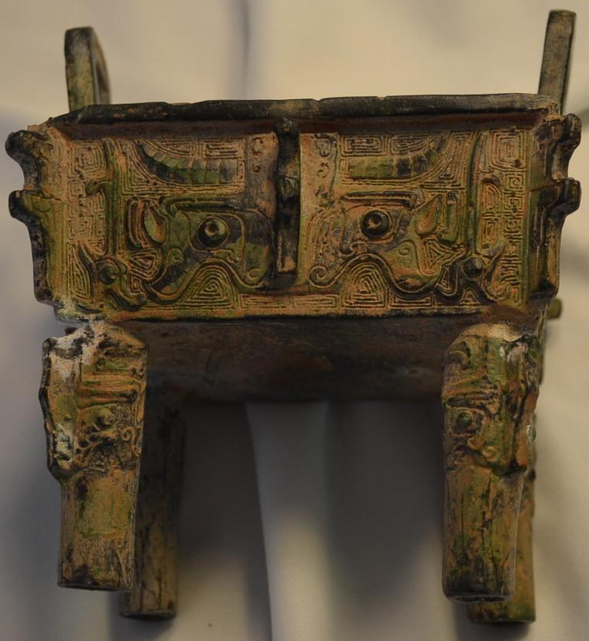

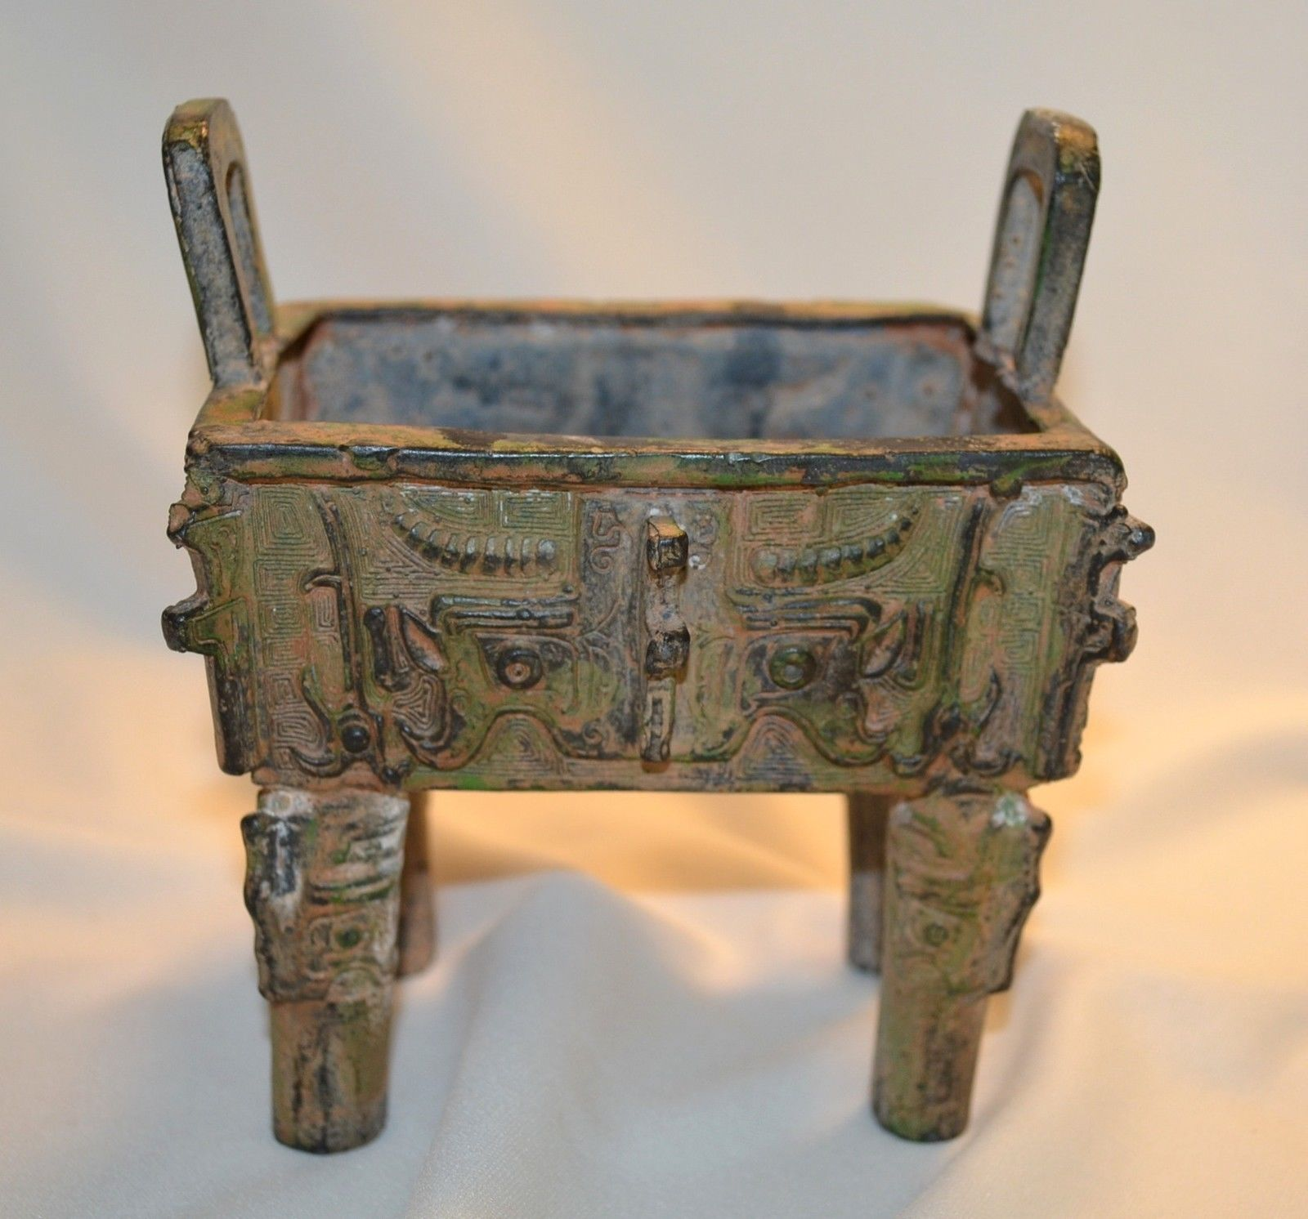

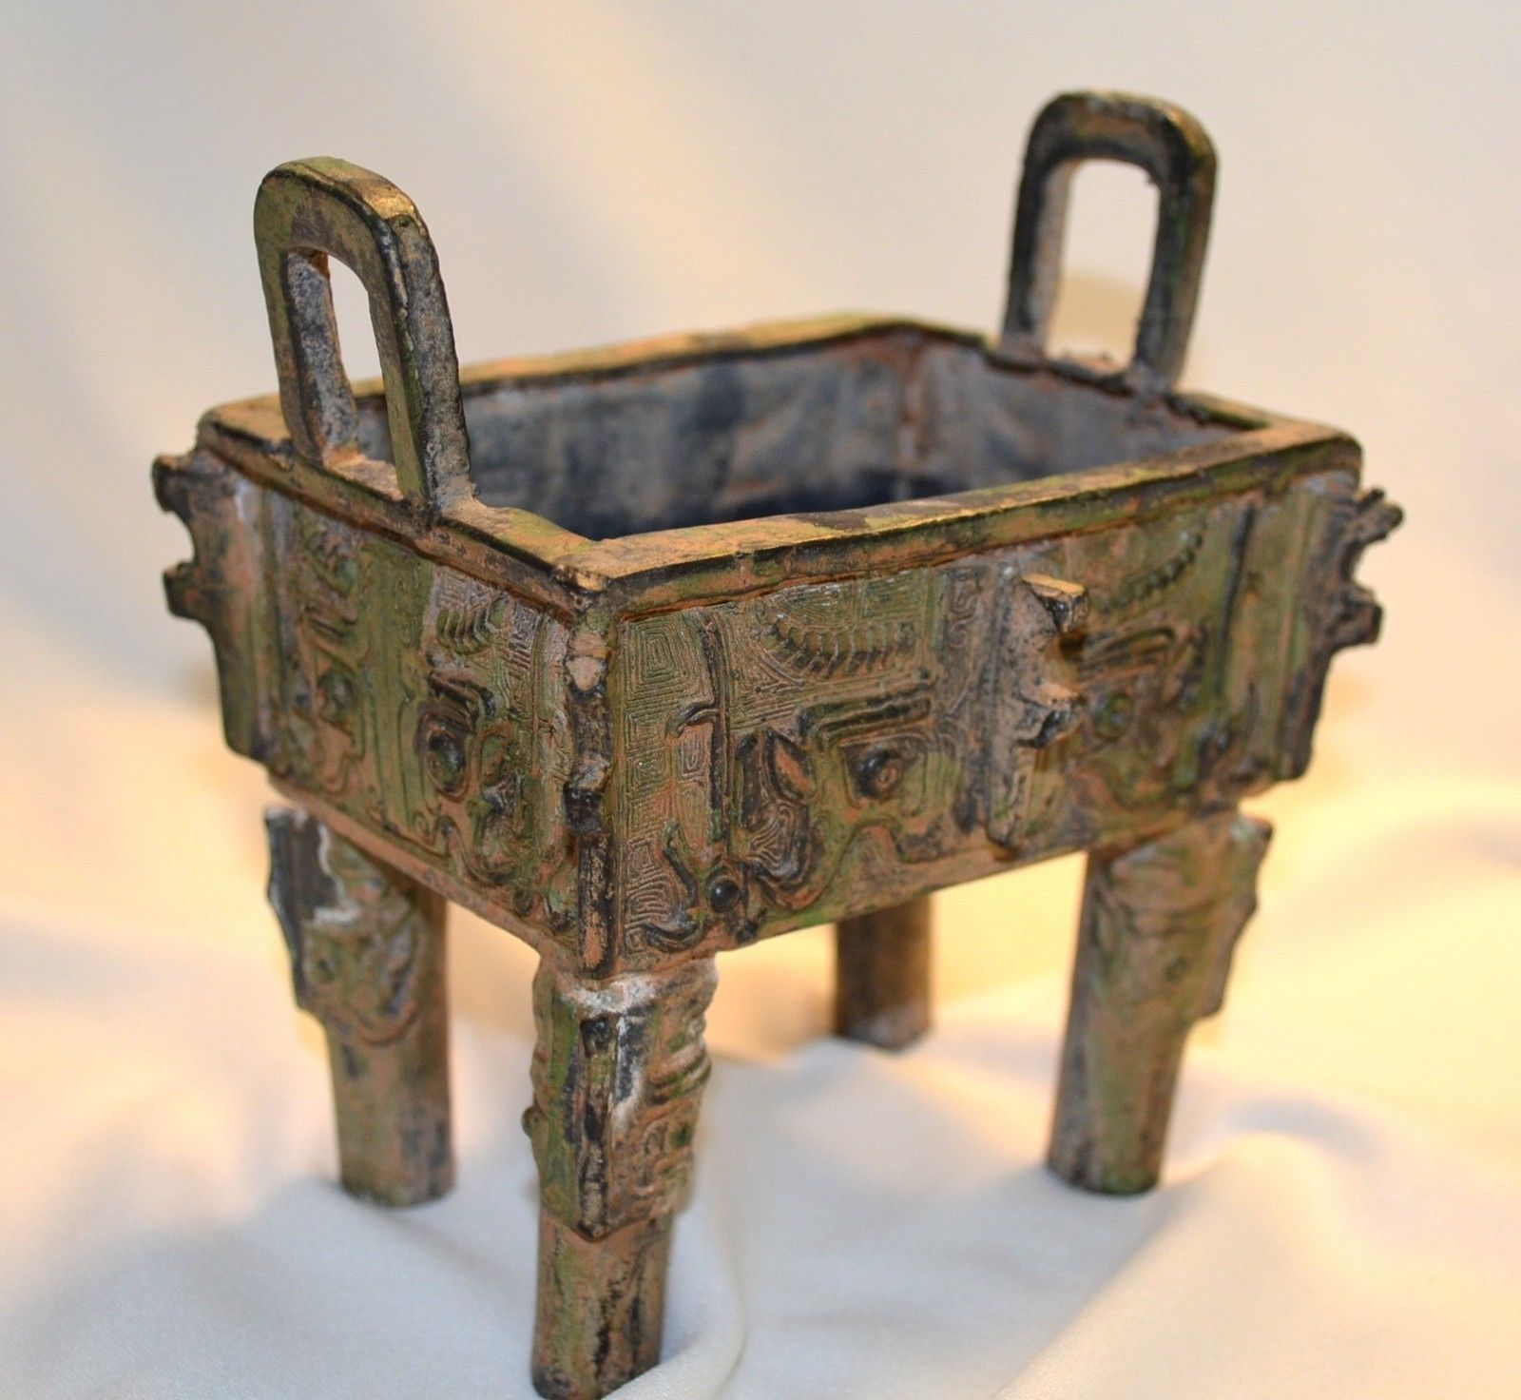 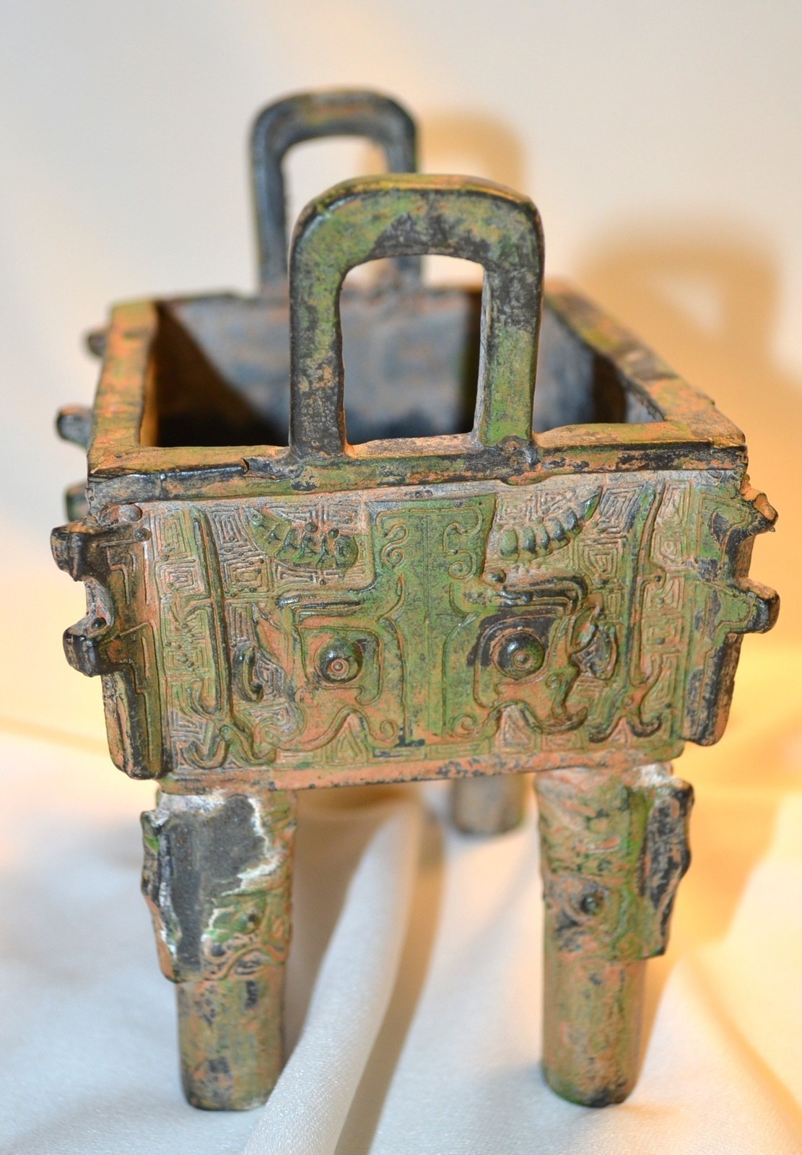 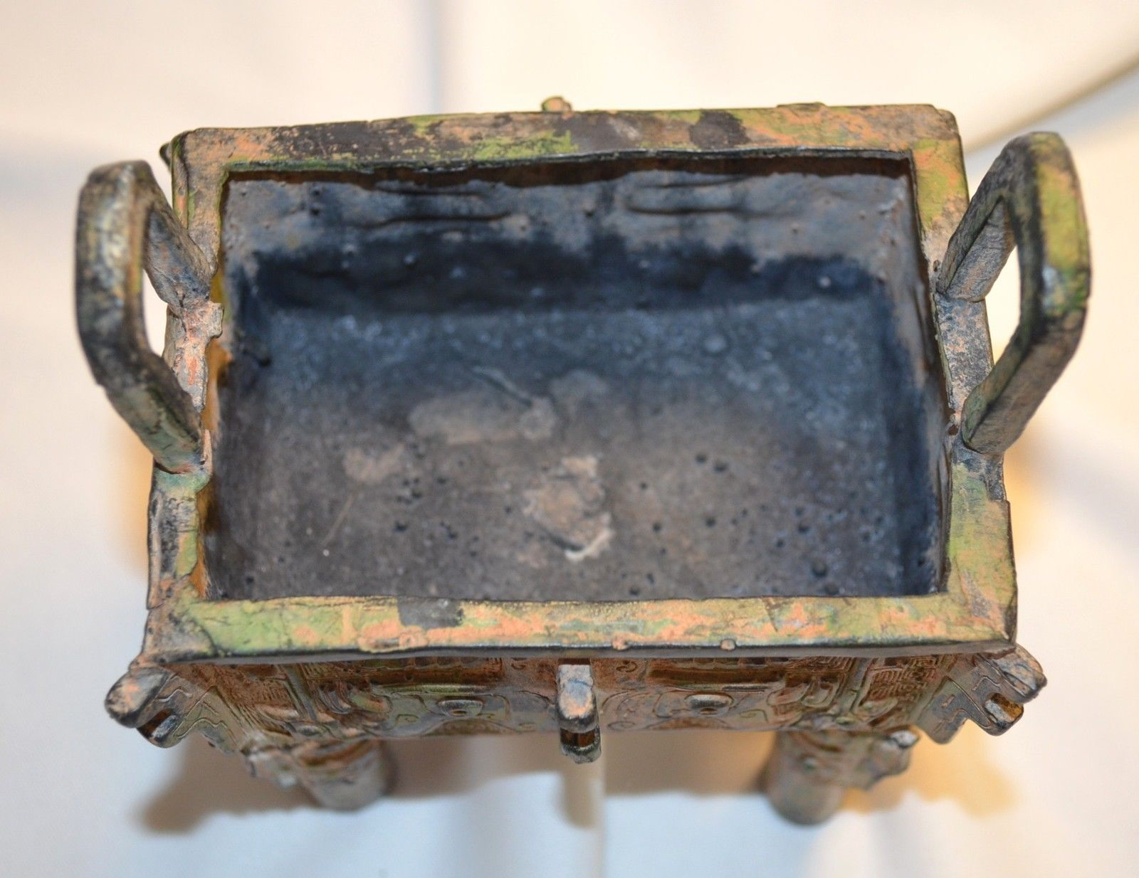 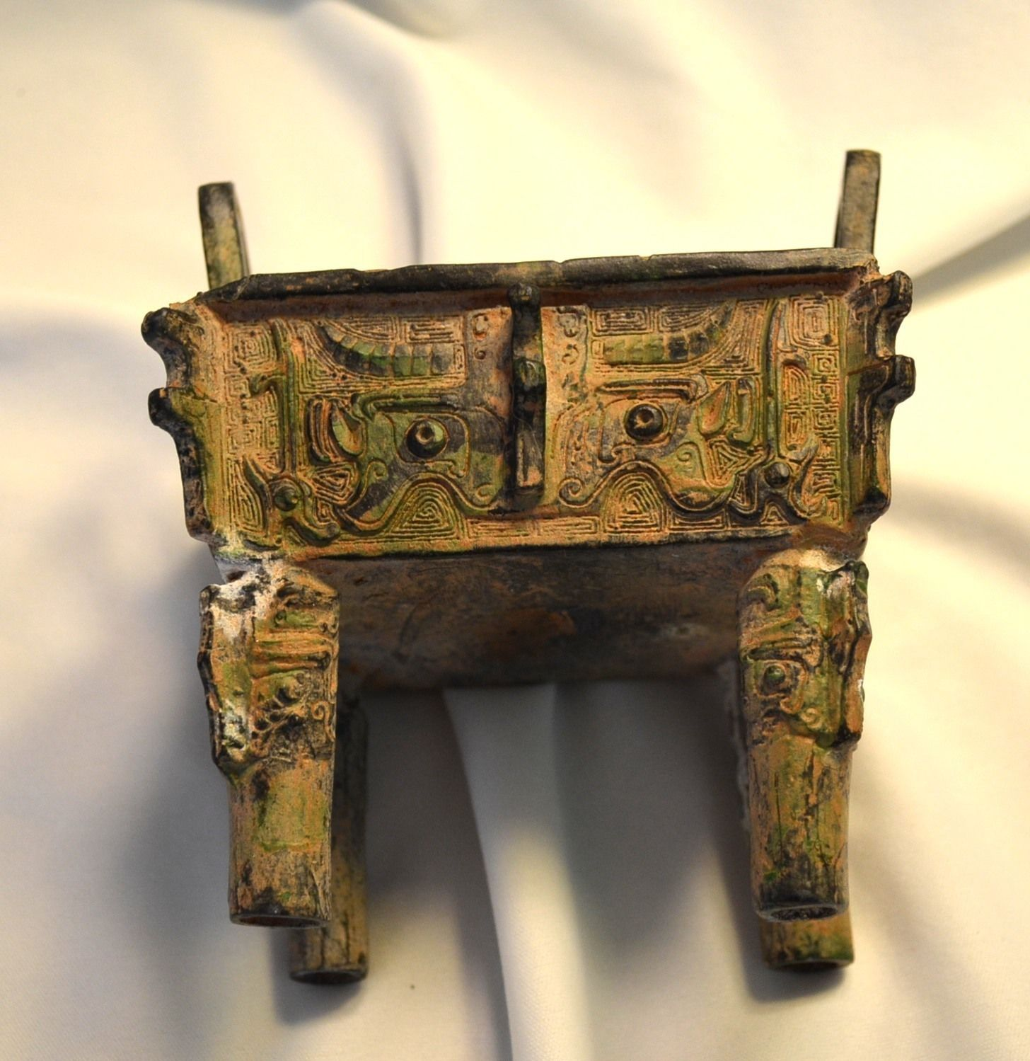

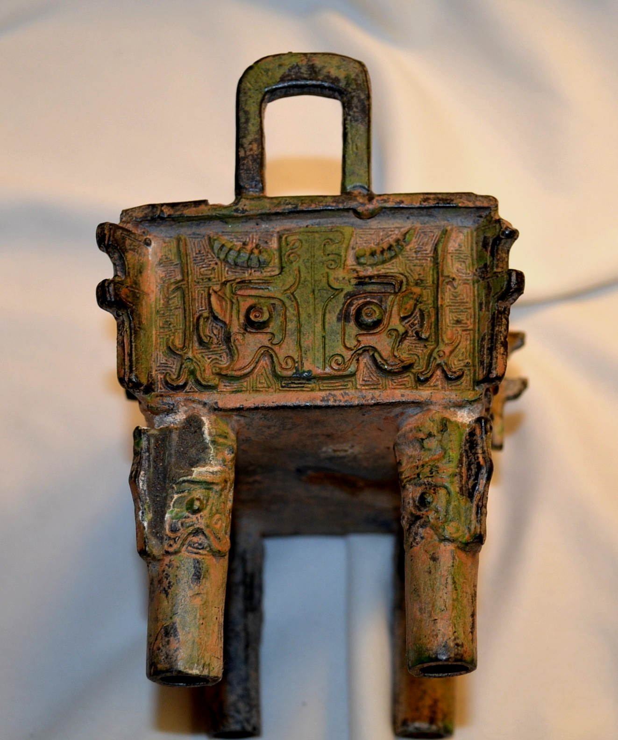

Case No.: 5

**Accession No.**

**Formal Label:**

**Display Description:**

**LC Classification:**

**Date or Time Horizon:**

**Geographical Area:**

**Map:**

**GPS coordinates:**

**Cultural Affiliation:**

**Media:**

**Dimensions:**

the body is 4 inches long; 3 1/4 inches wide; 4 inches high (handles add 7/8 inch to height), legs are 2 1/3 inches, handles are 7/8 inches high by 1 1/8 inches wide

**Weight:** 21 oz.

**Condition:**

**Provenance:**

**Discussion:**

**References:**